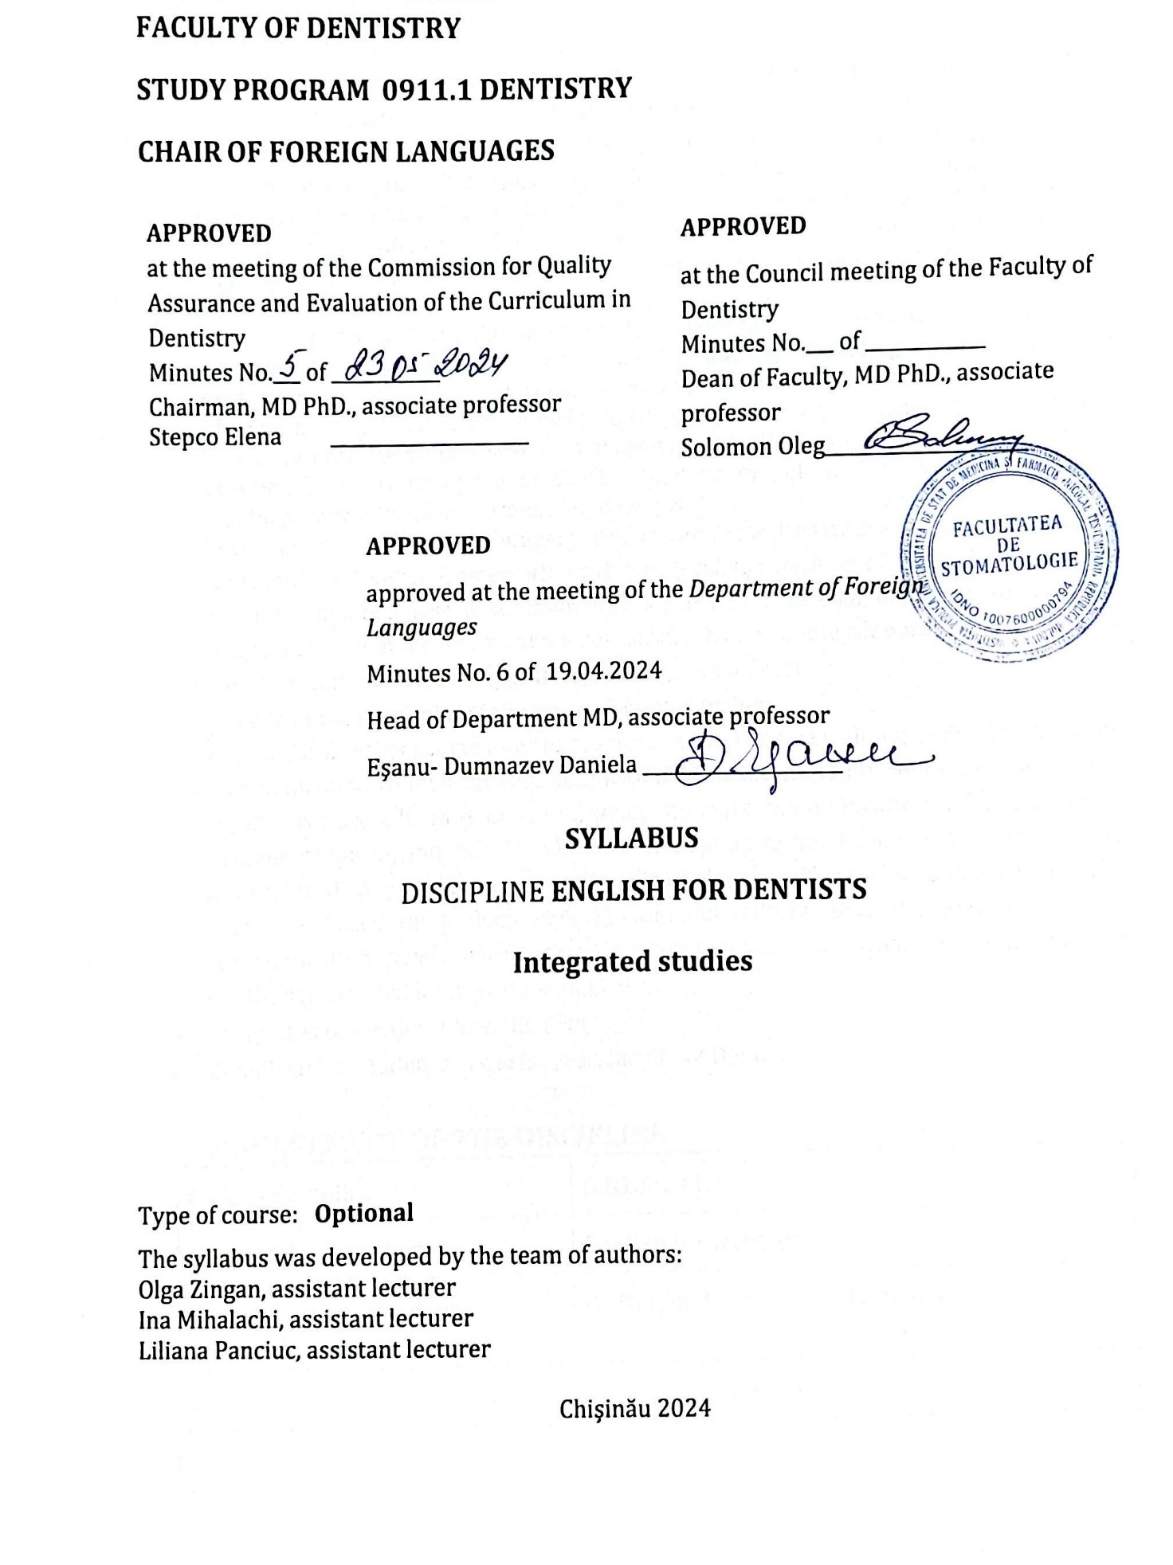

1. **INTRODUCTION**

* General presentation of the discipline: place and role of the discipline in the formation of the specific competences of the professional / specialty training program

The Modern Languages discipline plays a significant role in the curriculum of the "Nicolae Testemiţanu" State University of Medicine and Pharmacy, whereas the modern languages are considered as lingua franca and working languages among the EU institutions. Aligning to the Bologna process and European standards requires quality and linguistic competence assurance as a priority objective in the educational systems across Europe.

In accordance with these standards, the *English for Dentists* course is a theoretical and practical discipline designed for medical students, providing a comprehensive exploration of various aspects of communication in medical and intercultural contexts. The course is aimed at developing linguistic competences established by the Common European Framework of Reference for Languages (CEFR), developed by the Council of Europe. It aims to develop students’ solid linguistic competences necessary for academic mobility, intercultural and professional integration.

The formative orientation of university education, as well as training of medical students represent a reference framework for the professional training of medical personnel in order to enhance verbal communication skills in a foreign language, to facilitate communication in the international environment, to promote cooperation in the field of medicine, and to foster competitiveness in the job market.

* Mission of the curriculum (aim) in professional training

*English for Dentists* courseaims to provide comprehensive training in English language communication to medical students, with a focus on intercultural, online, visual, and medical contexts. Its mission is to develop students’ communication skills in a holistic manner, preparing individuals to be competent and empathetic in diverse situations - in intercultural environments, on social media platforms, and in real medical contexts. The course is based on a deep understanding of cultural diversity and the specific communication needs within these contexts, while also promoting empathy and sensitivity in social interaction with others.

* Languages of the discipline: English
* Beneficiaries: students of the Ist year, faculty of Dentistry.

**II. MANAGEMENT OF THE DISCIPLINE**

|  |  |  |  |
| --- | --- | --- | --- |
| Code of discipline | | **G.01.A.011.3** | |
| Name of the discipline | | **English for Dentists** | |
| Person(s) in charge of the discipline | | **O. Zingan, I. Mihalachi, L. Panciuc** | |
| Year | **I** | Semester/Semesters | **I** |
| Total number of hours, including: | | | **30** |
| Lectures | **10** | Practical/laboratory hours | **-** |
| Seminars | **10** | Self-study | **10** |
| Form of assessment | **E\*** | Number of credits | **1** |

**III. TRAINING OBJECTIVES WITHIN THE DISCIPLINE**

# *By the end of the course, the student will be able to:*

# at the level of knowledge and understanding:

* to define the concept of communication and identify the characteristics of different types of communication.
* to identify and understand cultural diversity in the process of communication in a foreign language.
* to know social media platforms and their specific communication strategies.
* to comprehend and interpret the information presented orally or in writing in English/French.
* to understand the importance of empathy in the doctor-patient relationship.
* to get familiar with the vocabulary associated with doctor-patient communication used in intercultural contexts, social media, etc.

# at the application level:

* to use specific English/French vocabulary and grammatical structures in authentic communication contexts.
* to demonstrate the ability to communicate in English/French with patients and colleagues in a coherent and efficient manner in intercultural contexts.
* to develop and use authentic audio-video materials and course-specific worksheets in English/French, using domain-specific terminology.
* to participate in simulations and role-playing games involving communication in English/French in medical or intercultural contexts.
* to write a summary in English/French using relevant vocabulary and lingvistic structures.
* to exhibit empathetic communication skills in English/French by adapting speech and language according to the needs and comprehension level of each individual.
* to deliver presentations and speeches in English/French as part of practical activities, addressing topics relevant to specialized medicine.

# at the integration level:

* to integrate knowledge and skills in the elaboration of an action plan and strategies focused at addressing specific issues and challenges of the Moldovan medical system, within the global context of medical development.
* to be able to merge knowledge aquired in the medical system of Moldova with international perspectives, identifying a coherent and viable conception for the development of the medical system of the country.
* to participate actively in national and international conferences, symposiums, and seminars to stay well-informed, share knowledge, and collaborate with professionals in the healthcare field.
* to identify and evaluate the role of personality in promoting and developing a model of expertise in medicine, including such qualities as empathy, effective communication, leadership skills, and professional ethics.

1. **TERMS AND PRECONDITIONS**

* B1 lingvistic proficiency in English/French, according to CEFR;
* Digital literacy (Internet usage);
* Communication and teamwork skills;
* Personal qualities: tolerance, compassion, autonomy.

1. **THEMES AND ESTIMATED ALLOCATION OF HOURS**

***Semester I (English)***

| No.  d/o | ТHEME | Number of hours | | |
| --- | --- | --- | --- | --- |
| Lectures | Practical hours | Self-study |
|  | Intercultural Communication: Building Connections in a Globalized World | 2 | 2 | 2 |
|  | Communication via Social Media. Advantages and disadvantages, barriers in communication. | 2 | 2 | 2 |
|  | Effective Phisician-Patient Communication. Challenges, strategies and conflict resolution skills. | 2 | 2 | 2 |
| 4. | Visual Communication: Types, purposes, means. Visuals in medical context. | 2 | 2 | 2 |
| 5. | Empathy in Medical Communication. Practical Techinques for Demonstrating Empathy. | 2 | 2 | 2 |
| 6. | Exam |  |  |  |
| 7. | **Total Semester I** | **10** | **10** | **10** |
| **Total** | | **30 h** | | |

1. **OBJECTIVES AND CONTENT UNITS**

**SEMESTER I (ENGLISH)**

| **Obiective** | **Unit content** |
| --- | --- |
| **Unit1. Intercultural Communication** | |
| * To define the concept of intercultural communication and to realize the importance of intercultural communication in a medical context. * to identify and manage cultural differences regarding values, beliefs, traditions, and medical practices, in order to ensure efficient and respectful doctor-patient communication. * to demonstrate empathetic communication skills in interacting with patients from diverse cultural backgrounds, through pair/group activities. * to develop skills in adapting to different styles of cultural communication. | Intercultural Communication: Building Connections in a Globalized World  *Comunicarea interculturală: construirea conexiunilor într-o lume globalizată* |
| **Unit 2. Communication via Social Media** | |
| * To understand the importance and impact of responsible communication on social media. * to demonstrate skills in drafting and delivering effective professional messages on various social platforms used in medical context. * to explore efficient communication strategies within the professional community, using social media platforms. * to integrate the skills of responsible and efficient use of social networks into activities aimed at educational, informative, and supportive purposes for both patients and the medical community. | Communication via Social Media. Advantages and disadvantages, barriers in communication.  *Comunicarea prin intermediul rețelelor de socializare. Avantaje și dezavantaje, bariere în comunicare.* |
| **Unit 3. Effective Phisician-Patient Communication** | |
| * To identify and explore different communication styles and patient approaches in a medical context. * to demonstrate active listening skills and empathy in communicating with patients in order to establish a relationship of trust and collaboration. * to become aware of/determine potential communication barriers in the professional environment and develop appropriate strategies to overcome them. * to promote open, transparent, and respectful communication to improve the quality of medical care and reduce conflict in doctor-patient interactions. * to be aware of the advantages and risks of using social media networks in daily life. | Effective Phisician-Patient Communication. Challenges, strategies and conflict resolution skills.  *Comunicarea eficientă medic-pacient. Strategii, provocări și căi de soluționare a conflictelor.* |
| **Unit 4.Visual Communication** | |
| * To understand the importance of visual communication in a medical context and to identify the types, purposes, and tools of their use. * to explore useful visual means in medical practice, such as medical images, diagrams, charts, and visual presentations. * to demonstrate skills in creating/using relevant and effective visual materials to communicate complex medical information. * to apply appropriate principles and technologies of visual design in creating visual materials that facilitate communication. | Visual Communication: Types, purposes, means. Visuals in medical context.  *Comunicarea vizuală: Tipuri, scopuri, mijloace. Mijloace vizuale in context medical.* |
| **Unit 5. Empathy in Medical Communication** | |
| * To define the concept of empathy and identify its importance in the context of medical communication. * to explore practical techniques for demonstrating empathy in interactions with patients and their families. * to develop skills in active listening and recognizing the emotional needs of patients during medical consultations. * to apply empathy in various medical situations, including cases of suffering, anxiety, or difficult decision-making. | Empathy in Medical Communication. Practical Techinques for Demonstrating Empathy.  *Empatia în comunicarea medicală. Tehnici practice pentru manifestarea empatiei.* |

1. **PROFESSIONAL (SPECIFIC (SC)) AND TRANSVERSAL (TC) COMPETENCES AND LEARNING OUTCOMES**

* **Professional (specific) (SC) competences**

PC1. Responsible achieving of professional tasks while applying the values and norms of professional ethics, as well as the provisions of current legislation. Applies the legal and regulatory framework in practical activities. Adheres to ethical and deontological norms, ensuring compliance with ethical-deontological standards and following the provisions of the medical code of ethics. Promotes collegial relationships with colleagues. Engages in free and independent activities in accordance with the medical profession's oath. Knows and respects the rights and technical norms regarding sanitary-hygienic and anti-epidemic regulations in various socio-medical situations according to current legislation. Understands and adheres to the provisions of the collective labor agreement, protection norms, and occupational safety and health techniques at the workplace. Ensures the conformity and correctness of fulfilling service obligations in providing care to the population in public, private, and community healthcare institutions. Encourages informed ethical decision-making and respects the patient's decisions.

PC4. Promotion of a healthy lifestyle, implementation of preventive measures, and self-care practices. Implements health promotion and disease prevention strategies. Identifies opportunities for maintaining health and preventing illness. Recognizes opportunities to promote lifestyle changes and other actions that positively contribute to overall health. Carries out health education activities in accordance with medical practice guidelines and protocols. Maintains personal health and demonstrates awareness of individual responsibility as a physician in promoting an evidence-based healthy lifestyle approach. Engages in discussions with patients regarding factors that may influence their health. Participates in and supports individuals or communities in health promotion activities, screening programs, and provides information on associated risks and benefits. Conducts individual-level preventive activities in line with clinical protocols. Promotes and applies strategies for personal health promotion and stress management in the workplace. Undergoes regular medical check-ups to maintain personal health.

PC5. Interdisciplinary integration of the doctor's activity within a team with the efficient use of all resources. Communicates, interacts, and works effectively within the team and with inter-professional staff, individuals, families, and groups of people. Interacts efficiently with other professionals involved in patient care, demonstrating respect for colleagues and other healthcare professionals. Develops positive collaborative relationships with team members involved in patient care, as well as the ability to adapt to change. Provides appropriate and timely support for service users in navigating the healthcare system, including services, access to care, and available resources. Efficiently utilizes linguistic skills, informational technologies, and communication competencies.

PC6. Conducting scientific research in the field of health and other branches of science.  
Plans, organizes, and carries out scientific research in the field. Identifies information sources, selects research materials and methods, conducts experiments, performs statistical analysis of research results, and formulates conclusions and recommendations. Develops and delivers speeches and presentations at scientific events, demonstrating personal engagement, coherence in presentation, and scientific accuracy. Participates in discussions and debates during scientific events.

PC7. Promoting and ensuring the prestige of the medical profession and raising professional standards. Plans, organizes, and conducts scientific research in the field. Identifies sources of information, selects research materials and methods, conducts experiments, performs statistical analysis of research results, and formulates conclusions and recommendations. Prepares and delivers speeches and presentations at scientific events, demonstrating personal engagement, coherence in delivery, and scientific accuracy; actively participates in discussions and debates at scientific events. Maintains a high level of professional competence throughout the entire career. Actively participates in professional associations to ensure ethical fulfillment of professional duties, and to promote the image of the physician and the healthcare system within society. Contributes to aligning the legislative framework in healthcare with European standards, ensuring the quality of medical practice, implementing Good Practice Guidelines, and promoting the image of the medical profession at scientific-practical events and in the media.

PC8. Carrying out pedagogical and methodological-didactic activities within higher and vocational technical education institutions in the field of health. Conducts small-group teaching activities for medical students and nursing trainees. Carries out workplace-based assessments, including the ability to provide constructive feedback. Understands and applies instructional methods appropriate to the specific audience. Defines the goals and objectives of teaching and/or assessment. Determines the most suitable forms of instruction and evaluation based on the learners’ profile. Develops curricula, work plans, and methodological-didactic materials for the training of students/learners/trainees. Implements health promotion measures within the community.

* **Transversal competences (TC)**

TC1. Autonomy and responsibility in the activity. Application of strict and efficient work rules, demonstrating a responsible attitude towards carrying out professional tasks while applying the values and norms of professional ethics, as well as complying with current legislation. Promotion of logical reasoning, practical applicability, evaluation, and self-evaluation in decision-making.

TC2. Effective communication and digital skills. The efficient use of linguistic knowledge, skills in information technologies, research competencies, and informational sources (Internet portals, email, databases, software applications, online platforms, etc.) in both Romanian and an international language.

**Learning outcomes**

*Upon completion of the course unit the student will be able to:*

* Define the concepts of communication, intercultural communication, and professional communication.
* Distinguish various types and means of communication.
* Integrate the acquired knowledge in professional communication.
* Communicate efficiently in an intercultural environment, recognizing and respecting cultural diversity.
* Responsibly and efficiently use social media platforms to communicate clear and appropriate messages to the target audience.
* Create and interpret visual materials to support verbal messages.
* Demonstrate empathy in communicating with patients in a medical context, using clear language adapted to the patient's understanding.
* Recognize and respond to the emotional needs of patients, promoting an empathetic and supportive medical care environment.
* Appreciate the importance of using precise and appropriate specialized vocabulary in English/French.
* Produce texts in both oral and written communication in English/French.
* Utilize information technologies to enhance linguistic skills in English/French and access relevant resources in these languages.
* Communicate in English/French contexts, including interactions with patients and colleagues in the medical team.

1. **STUDENT'S SELF-STUDY**

|  |  |  |  |  |
| --- | --- | --- | --- | --- |
| No. | Expected product | Implementation strategies | Assessment criteria | Implementation terms |
| 1. | Thematic projects | Development of thematic communications (PPT, posters).  Compilation of syntheses and summaries. | The ability to identify relevant information on the studied subject and present it in a coherent and logical manner. | Throughout the course |
| 2. | Thematic video projects | Watching video documents;  Completing audio comprehension checklists. | Developing interpretative skills in presenting the content of a video document. | Throughout the course |
| 3. | Individual portfolios | Completing individual portfolios with relevant informational resources related to the studied subject. | The degree of completion and independent activity. | Throughout the course |

1. **METHODOLOGICAL SUGGESTIONS FOR TEACHING-LEARNING-ASSESSMENT**

* **Teaching and learning methods used**
* Presentation, conversation, exercise, demonstration, problematization, brainstorming, case study, debates, and discussions are traditional teaching and learning methods.
* Interactive methods with an emphasis on the pragmatic aspect of communication and creative exploration include free associations, the T-chart, Venn Diagram, role-playing, word games and puzzles, listening activities, and auditory comprehension, mind mapping, projects, exhibitions, and presentations, as well as online games like horse racing, millionaire, etc.
* **Applied teaching strategies / technologies**
* Inductive strategies (from specific to general);
* Deductive strategies (from general to specific);
* Analogical strategies (using models);
* Transductive strategies;
* Mixed strategies: inductive-deductive and deductive-inductive;
* Algorithmic strategies: explanatory-demonstrative, intuitive, expository, imitative, programmed, and algorithmic proper;
* Heuristic strategies - for the elaboration of knowledge through personal thinking effort, using problematization, discovery, modeling, hypothesis formulation, heuristic dialogue, investigative experiment, idea assault, with the effect of stimulating creativity.
* **Methods of assessment** (including the method of final mark calculation)

**Current**:

Formative assessment: frontal and/or individual control through

* Problem/exercise solving
* Case study analysis
* Role-playing on discussed topics.

Portfolio (summative assessment method).

**Final mark:** Sem. I – Annual average - 50%, Exam - 50%.

**Method of mark rounding at different assessment stages**

|  |  |  |
| --- | --- | --- |
| Intermediate grading scale (annual average  marks and examination scores) | National Assessment System | ECTS Equivalent |
| **1,00-3,00** | **2** | **F** |
| **3,01-4,99** | **4** | **FX** |
| **5,00** | **5** | **E** |
| **5,01-5,50** | **5,5** |
| **5,51-6,0** | **6** |
| **6,01-6,50** | **6,5** | **D** |
| **6,51-7,00** | **7** |
| **7,01-7,50** | **7,5** | **C** |
| **7,51-8,00** | **8** |
| **8,01-8,50** | **8,5** | **B** |
| **8,51-9,00** | **9** |
| **9,01-9,50** | **9,5** | **A** |
| **9,51-10,0** |  |

The average annual mark and the marks for all stages of the final examination (computer assisted, test, oral) - are expressed numerically according to the grading scale (see the table). The final mark obtained is expressed as a number with two decimals and is recorded in thestudent’s record book.

Absence from the examination without a valid reason is recorded as &quot;absent&quot; and is equivalent to a score of 0 (zero). The student is allowed up to two re-examinations for the failed exam.

**X. RECOMMENDED LITERATURE:**

*A. Compulsory :*

1. Barker, Alan. *How to improve your communication skills*. UK,  London,  British Library,2022
2. Gibson, Robert. *Intercultural Business Communication*. Oxford University Press, 2002
3. Plutchik, R. *Evolutionary bases of empathy. Empathy and its development*. 1987;1:38–46.

*B. Additional*

* <https://www.youtube.com/watch?v=JzJNA-3b6NA&t=414s>
* <https://www.youtube.com/watch?v=SSJFJpk0osU>
* <https://www.youtube.com/watch?v=FtInxBo4Et4>
* <https://khanmisbah82.medium.com/what-is-social-media-53eac1b43794>
* <https://en.wikipedia.org/wiki/Social_media>
* <https://www.geeksforgeeks.org/what-is-social-media/>
* <https://www.lifewire.com/what-is-social-media-explaining-the-big-trend-3486616>
* <https://youtu.be/LgarEgc3PTc>
* <https://youtu.be/ZcBBHxlH7-w>
* <https://youtu.be/GSdMK8abuBk>
* <https://leopardtech.pages.dev/posts/12-ways-to-use-social-media-for-education-587289/>
* <https://www.theasianschool.net/blog/role-of-social-media-in-education/>
* <https://www.theasianschool.net/blog/role-of-social-media-in-education/>
* <https://www.youtube.com/watch?v=ezLQxKood8A>
* <https://www.youtube.com/watch?v=bNuosP8ty1E>