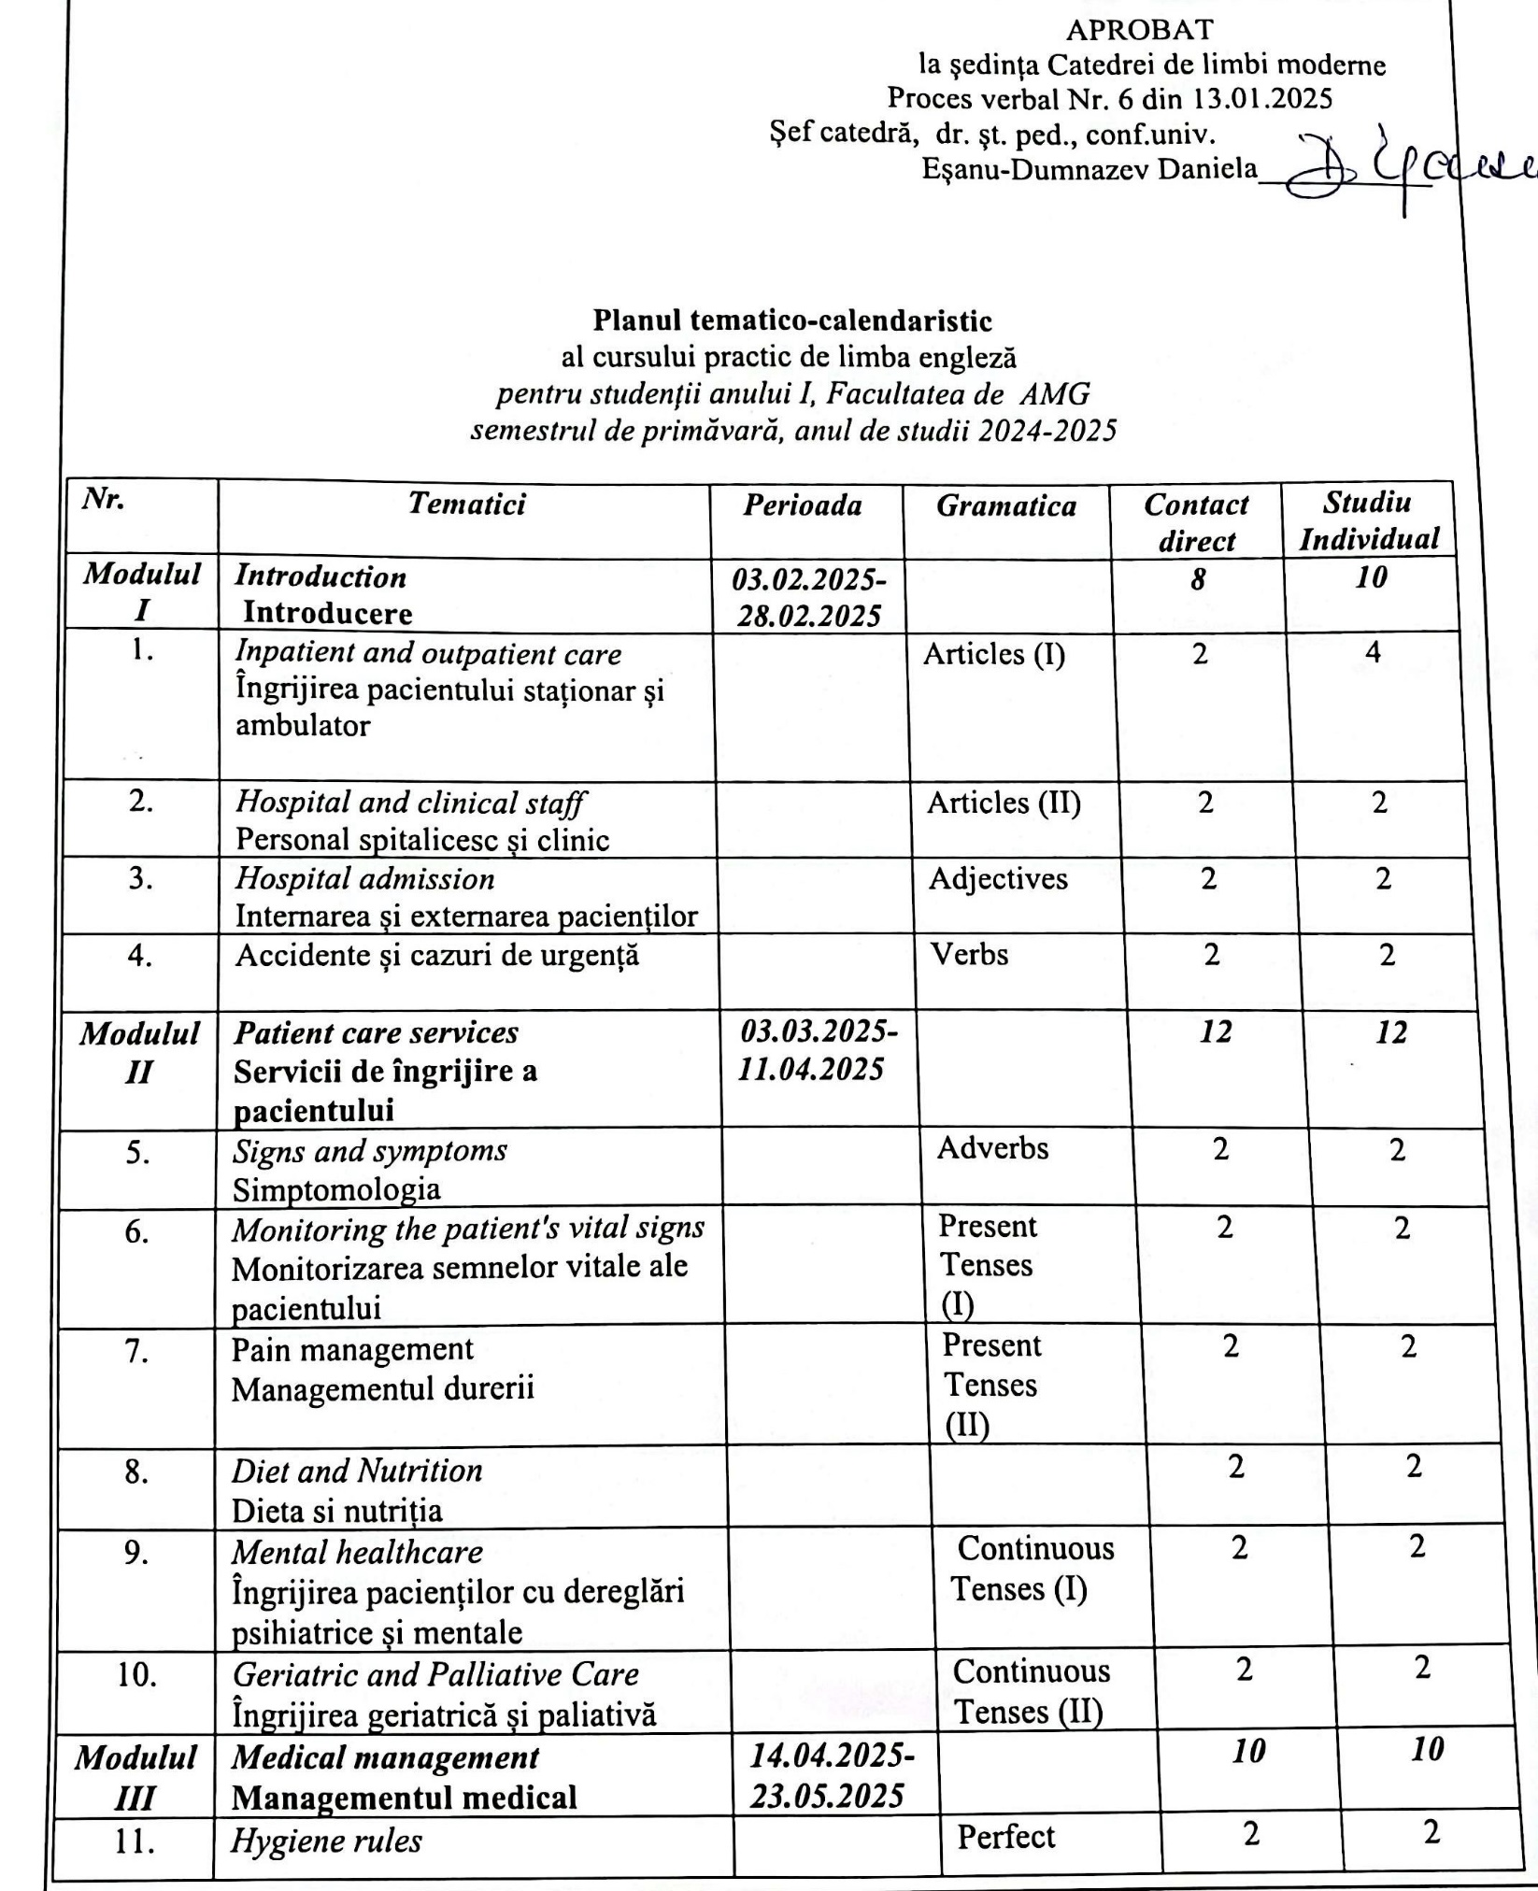

|  |  |  |  |  |  |
| --- | --- | --- | --- | --- | --- |
| ***12.*** | *Final Achievment Test*  Test de evaluare a cunoștințelor |  |  | 2 |  |
| ***13.*** | Exam |  |  | 2 |  |
|  | ***Total*** |  |  | ***30*** | |
|  |  |  |  |  | |

Planul calendaristic a fost elaborat de: *Viorica Cazac, lector universitar*