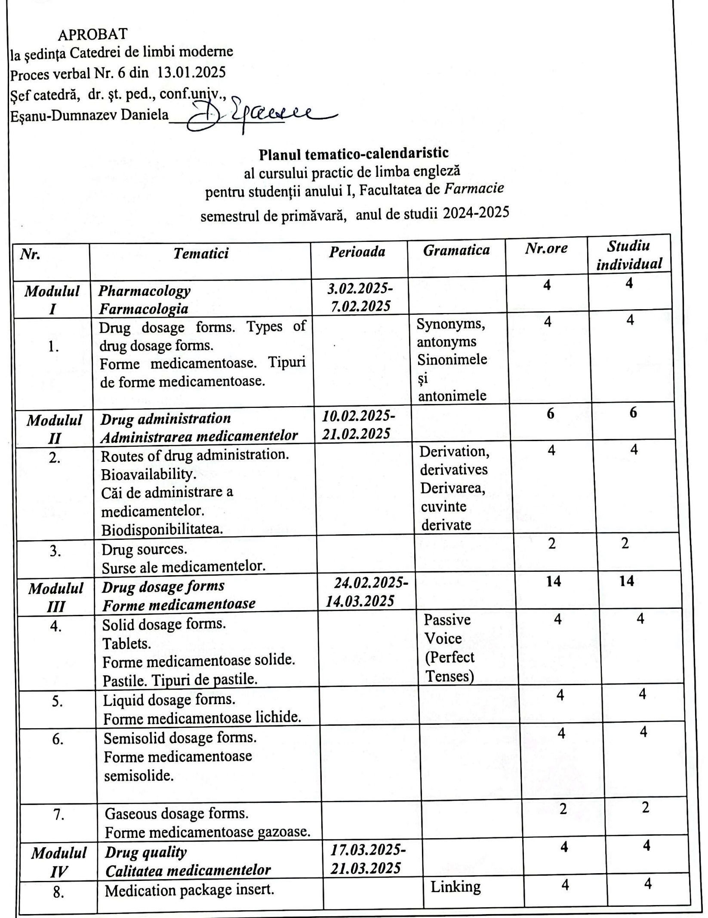

|  |  |  |  |  |  |
| --- | --- | --- | --- | --- | --- |
| ***Modulul VI*** | ***Pharmacology*** | ***24.03.2025-***  ***28.03.2025*** |  | **2** | **2** |
| 9. | Introduction into pharmacology. Pharmacology – historical development. Pharmacy branches.  Introducere în farmacologie. Farmacologie - dezvoltare istorică. Domenii farmaceutice. |  | Gerund (I) Gerunziul | 2 | 2 |
| ***Modulul VII*** | ***Drug classes***  ***Clasificarea medicamentelor*** | ***31.03.2025-16.05.2025*** |  | ***24*** | ***24*** |
| 10. | Drug nomenclature, standards and classes. Nomenclatura, standardele și clasele medicamentelor. |  | Gerund (II) Gerunziul | 4 | 4 |
| 11. | Neuropharmacologic drugs.  Medicamentele neurologice |  | Adjective | 4 | 4 |
| 12. | Antihistamines  Antihistaminele |  | Passive Voice (Present Tenses) | 2 | 2 |
| 13. | Cardiovascular drugs  Medicamentele cardiovasculare |  | Passive Voice (Past Tenses) | 4 | 4 |
| 14. | Gastrointestinal drugs  Medicamentele pentru afecţiuni gastrointestinale |  | Passive Voice (Future Tenses) | 2 | 2 |
| 15. | Antibiotics  Antibioticele |  | Discourse connectors | 4 | 4 |
| 16. | Antiviral drugs  Antiviralele |  | Indirect Questions (I) | 4 | 4 |
| ***Modulul VIII*** | ***Drug toxicity and drug tolerance*** | ***19.05.2025-23.05.2025*** |  | ***6*** | ***6*** |
| 17. | Drug toxicity and drug tolerance.  Toxicitatea medicamentelor și toleranța la medicamente |  | Indirect Questions (II) | 4 | 4 |
| 18. | English Achievement Test  Test de evaluare finală |  |  | 2 | 2 |
|  | ***Total*** |  |  | ***60*** | ***60*** |

Planul calendaristic a fost elaborat de:*Liliana Panciuc, asistent universitar*