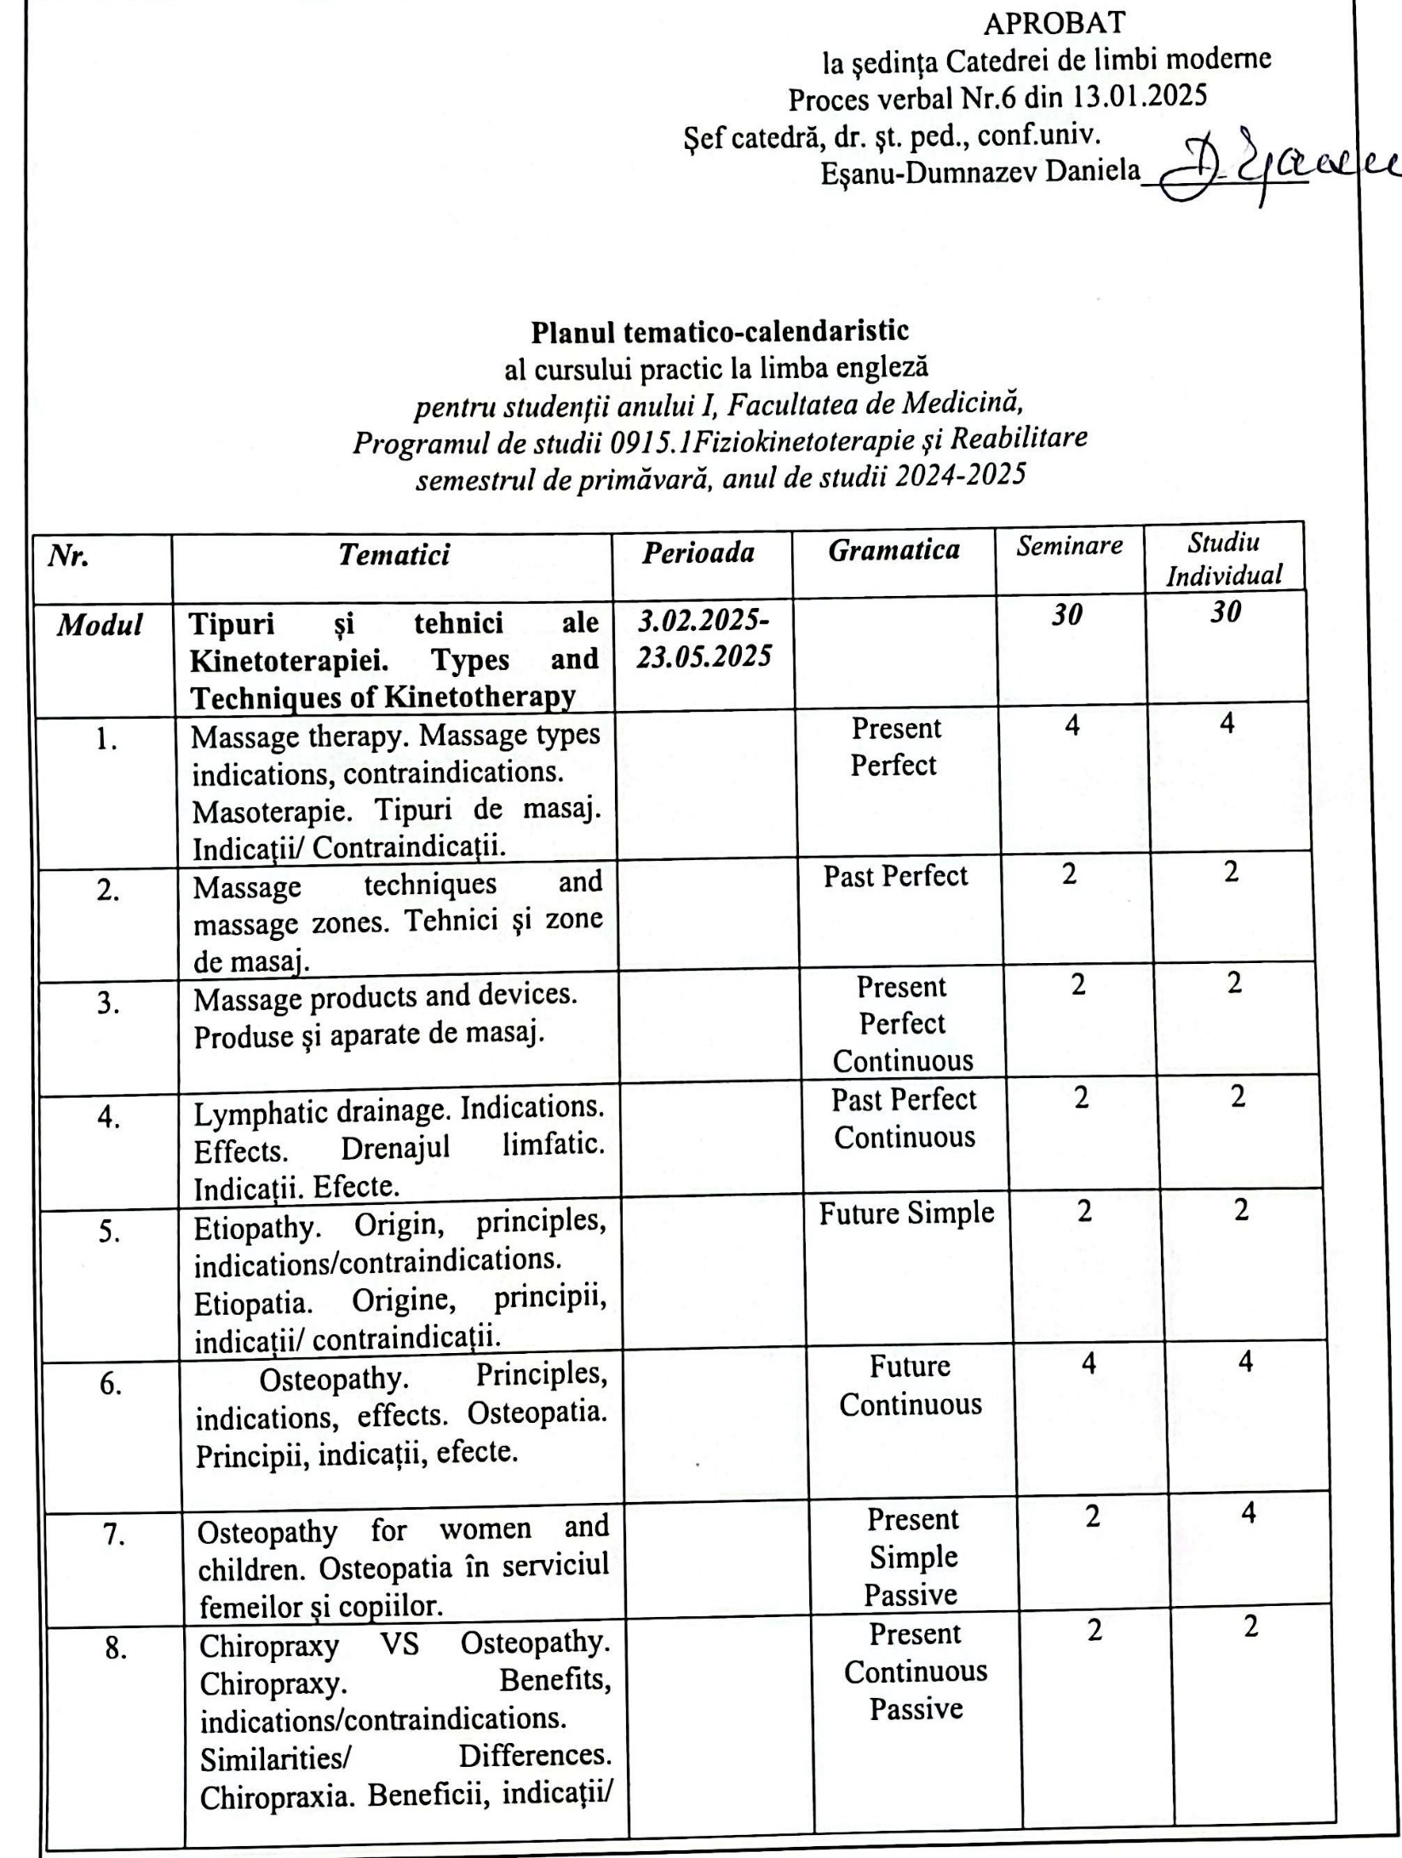

|  |  |  |  |  |  |  |  |
| --- | --- | --- | --- | --- | --- | --- | --- |
| 9. | Acupuncture. Benefits, indications, risks. Acupunctura. Beneficii, indicații, riscuri. |  | Past Simple Passive | 2 | 2 | | |
| 10. | Trigger point. Punctul Trigger. |  | Direct Speech | 2 | 4 | | |
| 11. | Fasciotherapy. Benefits, indications. Fascioterapie. Beneficii, indicații. |  | Indirect Speech | 2 | 2 | | |
| 12 | English achievement test  Test de evaluare |  |  | 2 |  | |
| 13. | Examination  Examen |  |  | 2 |  | |
|  | **Total** |  |  | ***30*** | | ***30*** |

Planul calendaristic a fost actualizat de: *Natalia Doronin, asistent universitar*