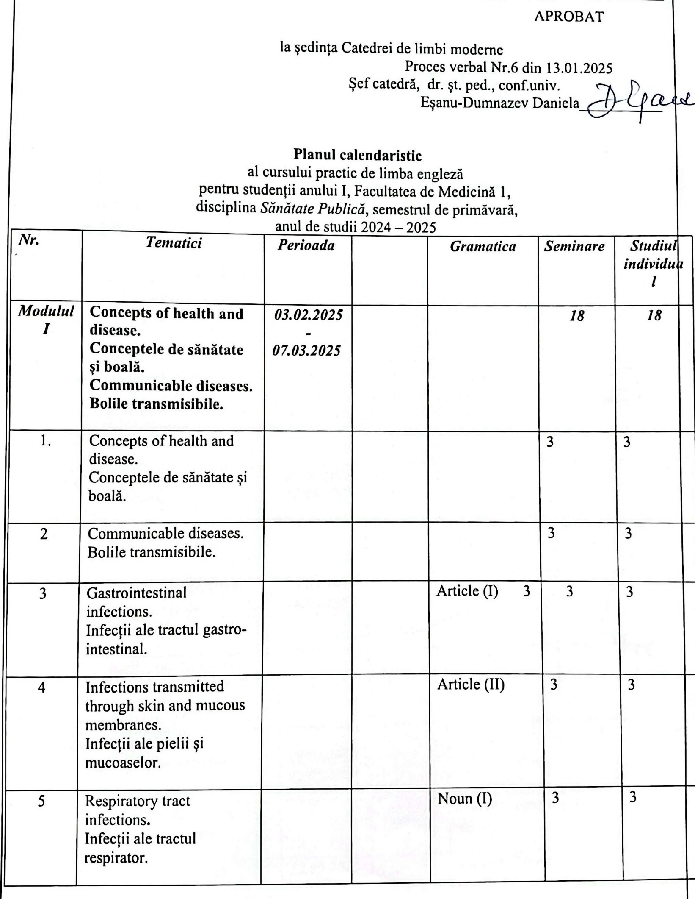

|  |  |  |  |  |  |  |
| --- | --- | --- | --- | --- | --- | --- |
| 6 | Arthropod- borne infections.  **Bolile transmise de insecte (artropode).** |  |  |  | 3 | 3 |
| ***Modulul II*** | **Non-communicable (genetic and acquired diseases)**  **Bolile netransmisibile.** | ***10.03.2025-***  ***04.04.2025*** |  |  | ***12*** | ***12*** |
| 7 | Non-communicable (genetic and acquired diseases)  **Bolile netransmisibile.** |  |  | Noun (II) | 3 | 3 |
| 8 | Cardiovascular diseases.  **Bolile cardiovasculare.** |  |  | Adjective (I) | 3 | 3 |
| 9 | Cancer. Cancerul. |  |  | Adjective (II) | 3 | 3 |
| 10 | Chronic respiratory diseases.  **Bolile cronice ale sistemului respirator.** |  |  | Adverb (I) | 3 | 3 |
| ***Modulul III*** | **Diabetes.  Diabetul.** | ***07.04.2025 11.04.2025*** |  |  | ***3*** | ***3*** |
| 11 | Diabetes.  Diabetul. |  |  | Continuous Tenses (II) | 3 | 3 |
| **Modulul**  **IV** | **Nutritional disorders.** **Tulburările de alimentație.** | ***14.04.2025***  ***18.04.2025*** |  |  | ***3*** | ***3*** |
| 12 | Nutritional disorders. **Tulburările de alimentație.** |  |  | Continuous Tenses (III) | 3 | 3 |
| **Modulul**  **V** | **Mental health.** **Sănătatea mintală.** | ***29.04.2025***  ***02.05.2025*** |  |  | ***3*** | ***4*** |
| 13 | Mental health issues. **Sănătatea mintală.** |  |  | Perfect Tenses (I) | 3 | 4 |
| **Modulul**  **VI** | [**Medical Sociology. Social Policy. Health Economics**](https://www.healthknowledge.org.uk/public-health-textbook/medical-sociology-policy-economics)**.** **Sociologia medicală, politicile sociale și economice în sănătate.** | ***12.05.2025 16.05.2025*** |  | Perfect Tenses (II) | ***3*** | ***4*** |
| 14 | [Medical Sociology. Social Policy. Health Economics](https://www.healthknowledge.org.uk/public-health-textbook/medical-sociology-policy-economics). **Sociologia medicală, politicile sociale și economice în sănătate.** |  |  | PerfectTenses (III) | 3 | 4 |
| 15 | Final test | ***19.05.2025***  ***23.05.2025*** |  |  | ***3*** |  |
|  | ***Total*** |  |  |  | ***45*** | ***45*** |

Planul calendaristic a fost elaborat de: *Olga Pascal, asistent universitar*